# A Gravity Adventure

# Development Plan

* Overview (Page 2)
* Mechanics (Page 3)
* Bosses (Page 5)

# Overview

**Introduction**

*A Gravity Adventure* is a 2D platforming game created for PC. The game is separated into 20 levels, where the player is required to reach an exit in order to proceed to the next level. Players can utilize different mechanics to their advantage to accomplish this goal, including something special: switching the orientation of the level.

Throughout the game, players will learn new mechanics. Every five levels the player will be confronted by a boss-like enemy who will force the player to utilize previous mechanics in order to proceed.

**Art Style**

The game will be presented with mostly simple geometric shapes and pixel art for sprites.

**Plot**

We actually don’t have a plot yet lol.

# Mechanics: Basic

Players will be introduced with mechanics slowly throughout the game

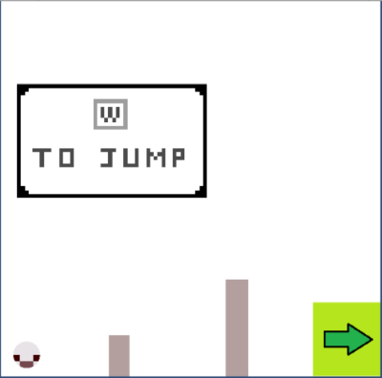**Stages**

Each level occurs in a walled interior room in the shape of a square. The player can start in anywhere on the stage with the final object to reach the exit, represented here with a green arrow.

Fig 1: Example Stage

**Player & Controls**

The player is an entity represented by the spherical ball. The player can move the character and interact with the environment through

|  |  |
| --- | --- |
| Basic movement (Key) | Movement |
| *A* | Player moves left |
| *W* | Player jumps |
| *D* | Player moves right |
| E | Player toggle switches |
| **<-** | Rotates screen towards left |
| **->** | Rotates screen towards right |

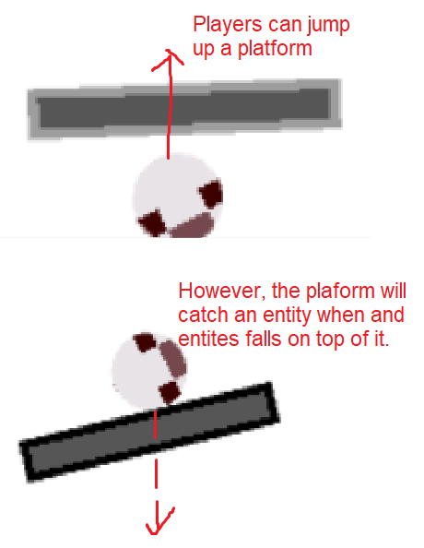**Neutral Objects** These objects do not harm you.

*Platform*: Player may stand on the platform.

*Blinking Platforms:* Platforms that will disappear after standing on it for a certain amount of time

*Blocks:* Square entities that fall with gravity

Fig 2: Platform Demos

*Sticky Surfaces:* A surface that will cause all entities that hit it to stick to it, until player hits Space to release the sticky surface.

*Bounce Surfaces:* Will cause all entities that hit it to bounce back.

*Fake Spikes:* Disguised as spikes, but will disappear when the player touches it.

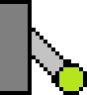**Input/output Objects**  
 Input objects can toggle output objects, altering their functions.

*Lever:* Has an on or off state that will toggle its outputs when the player presses “E” near it.

Fig 3: Lever

*Buttons:* Will be in “on” state when an object is colliding with the button. Some may have an extension, meaning that they can stay at the “on” state for a certain amount of time even after entities have left the button.

*Doors:* If a door is “off”, the door will act as a wall, but will allow entities through when it is “on”.

*Exit:* If it is on and the player collides with the exit, the player will progress to the next level.

Fig 4: Exit

**Harmful Objects** Harmful Objects will kill the player in different ways.

*Spike:* A triangle shaped object that will kill the player when the player touches it

*Turrets:* Shoot the player with projectiles, including:

*Bullets*: A small red projectile that travels in a straight path and kill the  
player on touch.

Fig 5: Turret

*Missiles:* A tracking projectile that turns toward the player as it   
accelerates and will kill the player on touch.

*Rogue Cube:* Move toward the player and will kill the player on touch.

# Levels and Bosses

**Levels**

|  |  |
| --- | --- |
| Level 1-4 | Introduction of basic movements |
| Level 5 | Monster and Buttons Boss (Kind of) |
| Level 6-9 | Input / Output training |
| Level 10 | Homing missile boss |
| Level 11-14 | Spikes levels |
| Level 15 | Psychic boss |
| Level 16-19 | Bounce pads + sticky surface levels |
| Level 20 | Homing Missiles 2 |
| Level 21-24 | Melee CPUs |
| Level 25 | CPU Boss |
| Level 26-29 | Combination of Mechanics Levels |
| Level 30 | Final boss |

**Bosses:**

*Monster and Buttons (Level 5):* In this level, a Rouge Cube will chase you and the player will need to trick the Rouge Cube into a button in order to progress.

*Homing Missiles (Level 10):* A turret, protected by spinning spikes around it, will assault the player with missiles. The player must outrun the missiles and trigger switches around the map to activate a laser that will destroy the boss.

Fig 6: Homing Missile Boss

*Psychic Boss (Level 15):* The boss will randomly change the orientation of gravity, which will throw the player into spikes. The player must dodge the spikes and stall for time in order to progress.

*Homing Missiles 2 (Level 20):* The previous homing boss makes a return, but bigger! There is no laser to kill the boss this time, but the player can utilize bounce pads around the map to deflect missiles from the boss.

*CPU Boss (Level 25):* The boss will overlook the level and drop Melee or Ranged CPUs into the level. The player must trick CPUs into spikes or trick them into shooting each other. After a few waves of CPUs, the boss will give up and allow the player to proceed.

*Final Boss (Level 30):* The boss will contain material from all previous bosses.